Curriculum Vitae

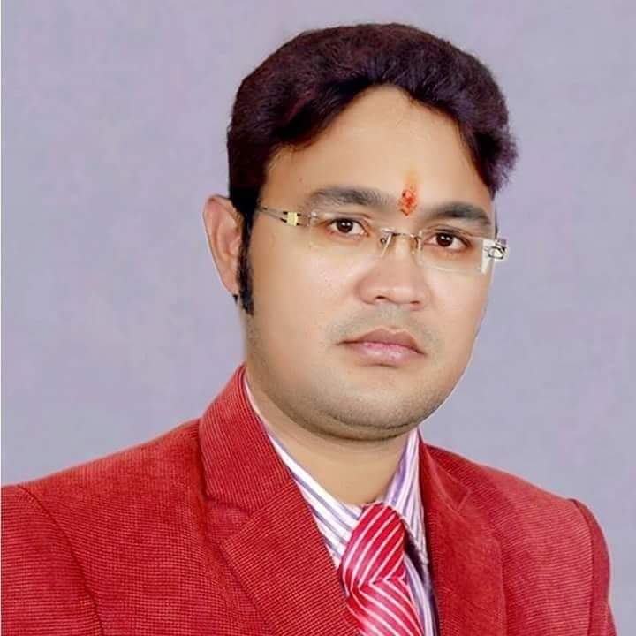
Dr. Upendra Kumar Dwivedi
Sr. Assistant Professor,
Department of English Studies & Research
D.A-V. College, Kanpur

Contact Information:
Address: [Kanpur]
Phone: [9936255745, 6394306072]
Email: [dwivediupendra2@gmail.com]
Website:

Objective:
I aim to continue contributing to the academic excellence of D.A-V. College, Kanpur, through dedicated teaching, extensive research, and active participation in academic and cultural activities. My focus is on fostering a deeper understanding of Indian English Literature and Vedic studies among students.

Educational Qualifications:
I hold a Ph.D. in English Literature from CSJMU Kanpur, awarded in 2015. Prior to this, I completed my M.Phil. from Algappa University Karaikudi Tamilnadu in 2007.
Academic Experience:
Since 2008, I have been serving as a Sr. Assistant Professor in the Department of English at D.A-V. College, Kanpur. My responsibilities include teaching undergraduate and postgraduate courses in English Literature, supervising M.Phil. and Ph.D. students, conducting research in Indian English Literature, organizing and participating in academic seminars and workshops, and engaging in curriculum development and academic planning.

Specialization:
My primary area of specialization is Indian English Literature.

Languages:
I am proficient in English as well as fluent in both Hindi and Sanskrit.

Publications:
I have authored a book entitled “Multiplicity of Themes in the Fiction of Bapsi Sidhwa” published by IIP, an Iterative International Publication in 2023. Additionally, I have published numerous papers in renowned journals.

Research Interests:
My research interests span Indian English Literature, Vedic Studies, and Comparative Literature with Sanskrit and Hindi Literature.

Current Projects:
I am currently working on a book that explores the relevance and application of ancient wisdom from the Shrimad Bhagwat Gita in contemporary society, focusing on its benefits for the new generation.

Academic and Cultural Activities:
I actively participated in seminars and conferences on Indian English Literature and Vedic studies. I hold a Vocal Prabhakar degree in music and specialize in singing bhajans, Ghazal, Hindi Songs and Sanskrit Hymns with playing Harmoniyum Instrument. Additionally, I am engaged in the continuous study of Vedic scriptures and philosophy.

Personal Traits:
I am known for my calm and composed demeanour. My personality reflects a balance between professional dedication and spiritual practices. I am deeply devoted to both my work and my spiritual pursuits.

Professional Affiliations:
I have been a member of National Science Congress and Altie Chapter since 2008.

